**DATA ANALYST REPORT**

**Defining the Objective**

* **Understand the Problem:** Start by clearly understanding the question or problem you need to solve.

**The Sample Data:**

* **Model Data Based on:** international trade June 2024
* **Data type:** .csv

**Data cleaning and preparation:**

* **Handle missing values:** Fill in, interpolate, or remove missing data points.
* **Remove duplicates:** Identify and delete duplicate records to avoid unwanted results.
* **Transform data:** calculated fields

**Make three questions by myself to analyse the Report:**

* What are the top five countries by export value, and how have they trended over the most recent periods?
* Which product types contribute the most to export value, and does this vary significantly across different regions?
* Is there any seasonal trend or pattern in export values over time, and how does this vary by country?

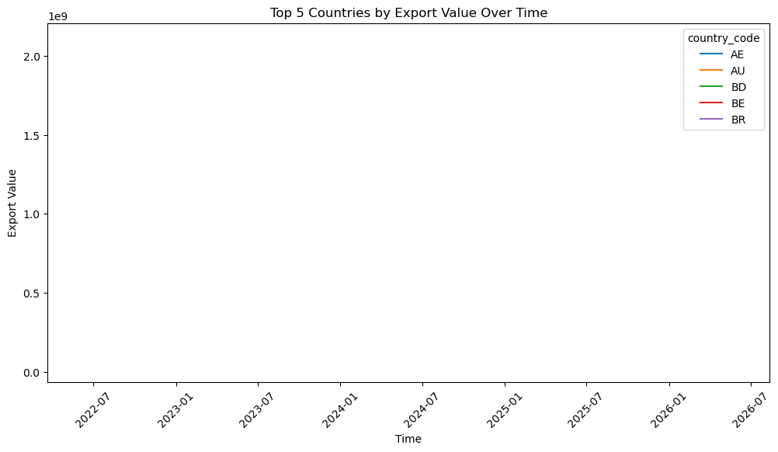**Outputs of the analysis report:**

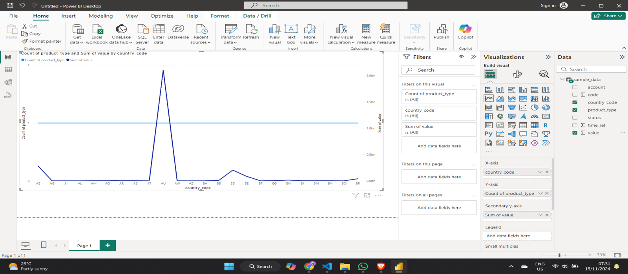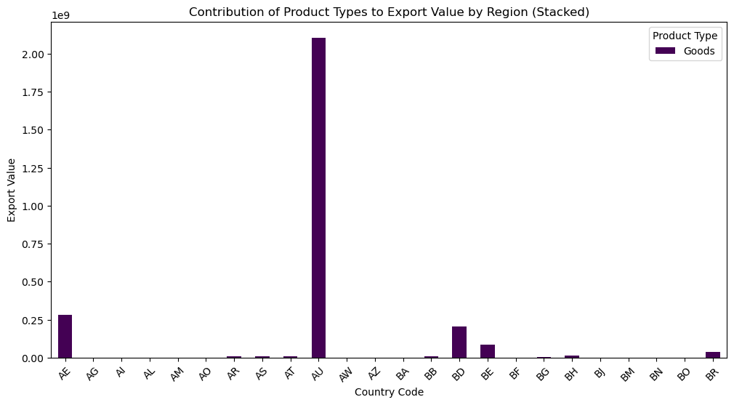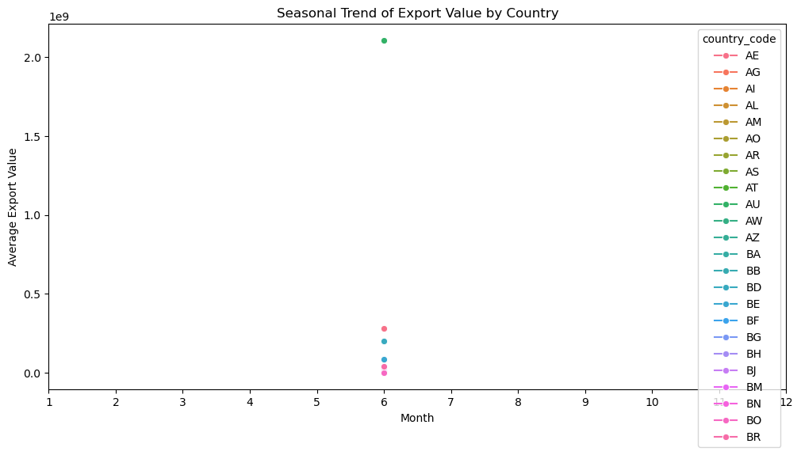

**PowerBI and Microsoft Fabric visualization:**